C programming(day-4)

1).reverse a number by using loop:

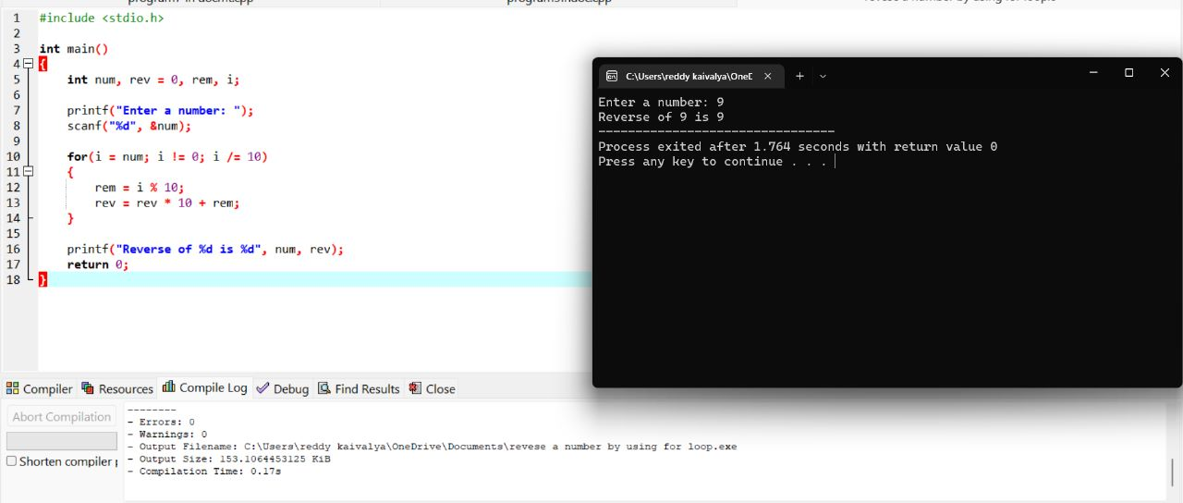2).TO FIND THE LARGEST NUMBER IN THE ARRAY:

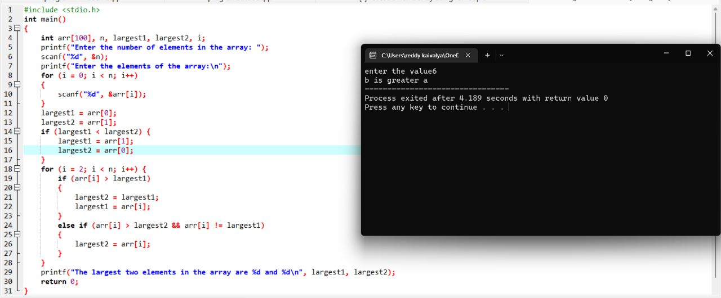3)Kth smallest element in an array :

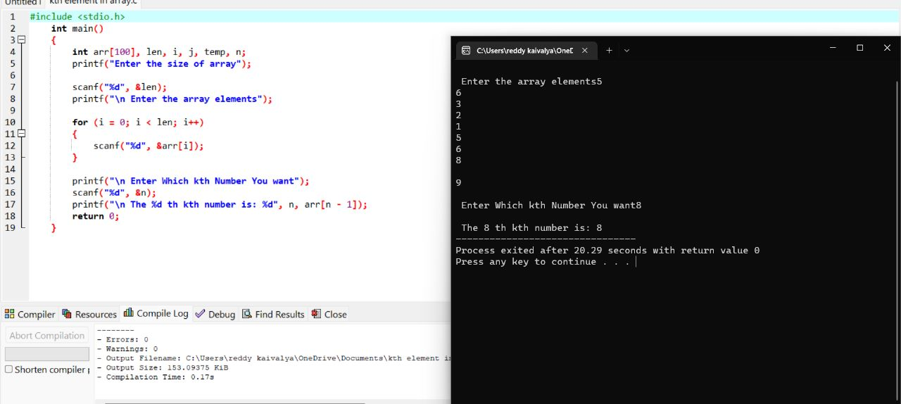

4).binary search method to display its position in a linear array:

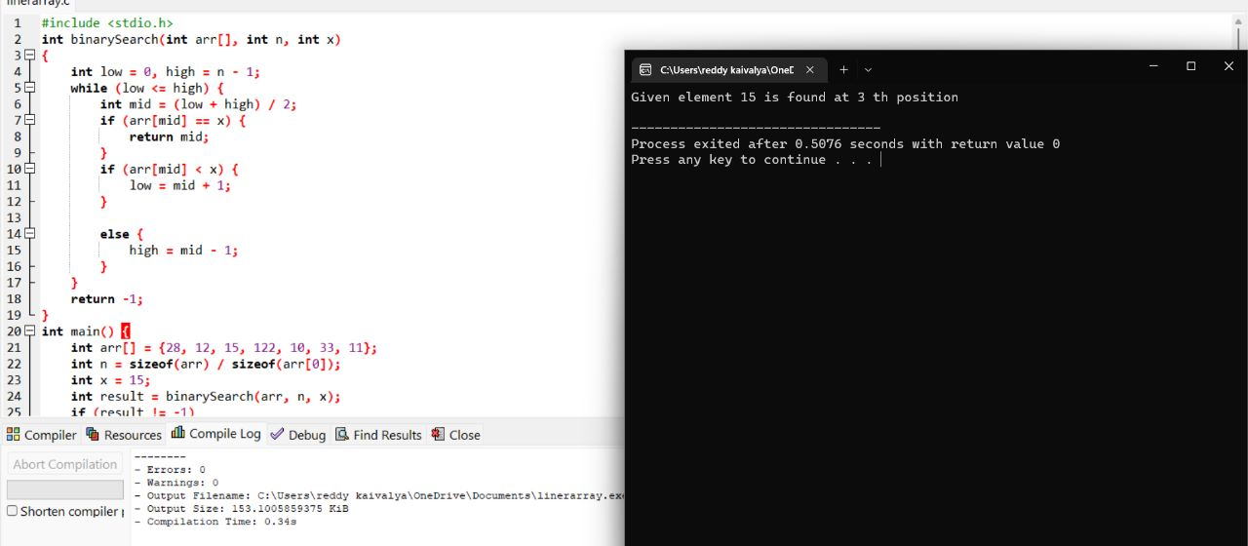

**5).sum of natural number using while loop:**

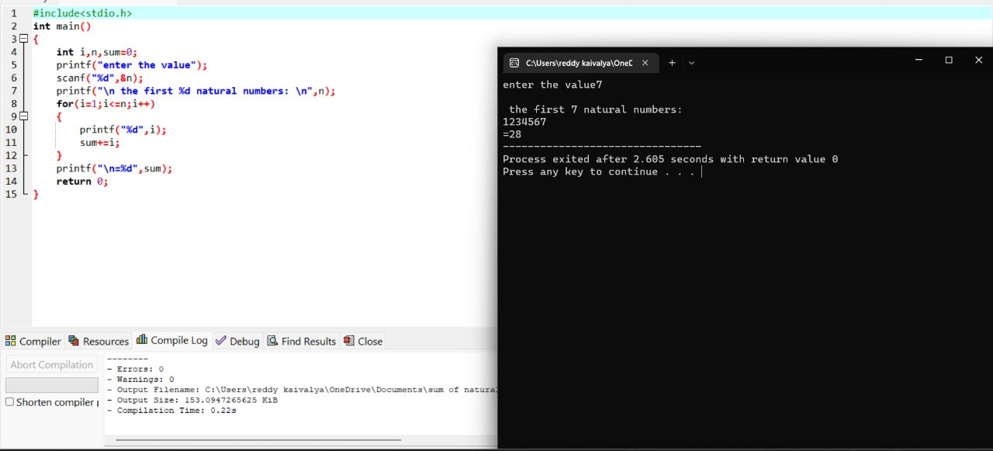

**6). To find GCD of two number using for loop:**

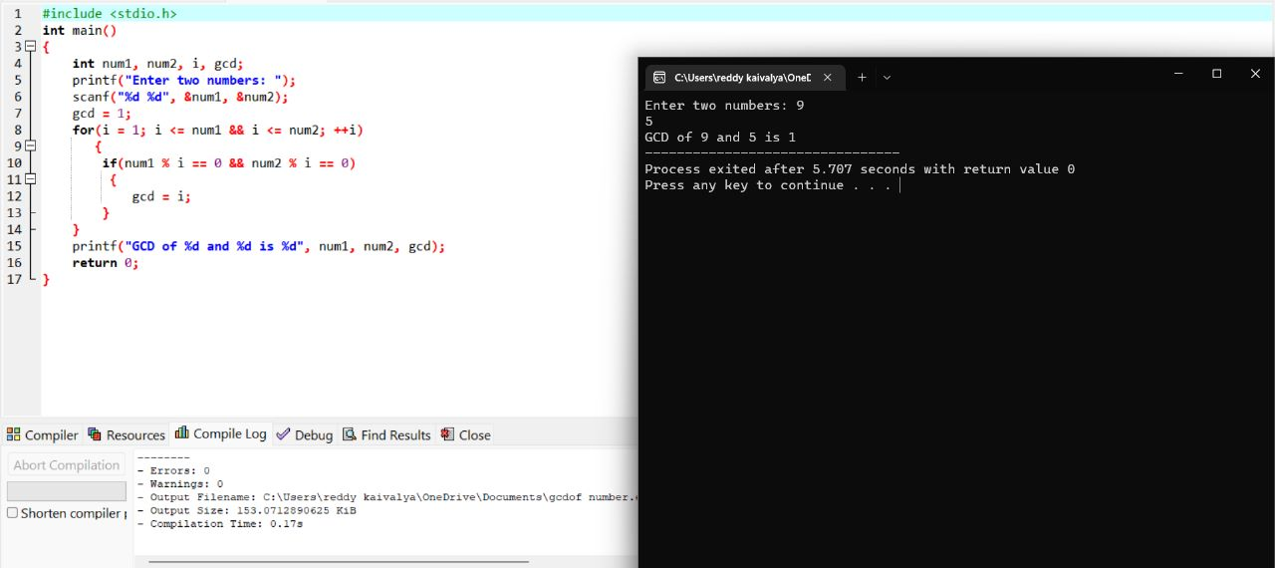

**7).predict the out put or errors for the following program:**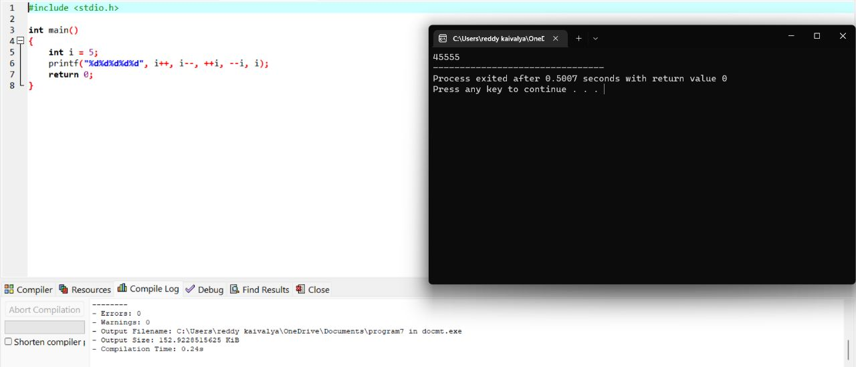

**8).predict the out put or errors for the following program:**

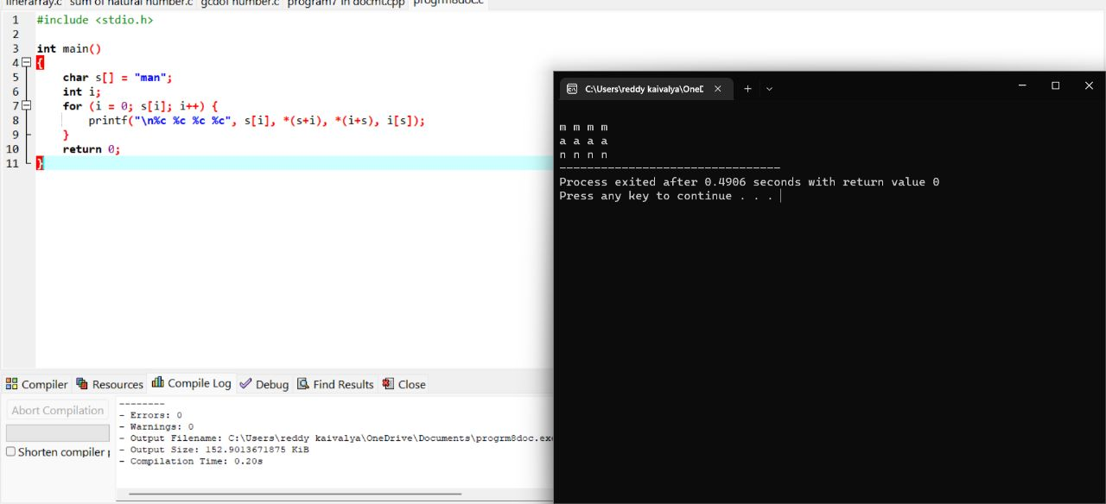

**9).predict the out put or errors for the following program:**

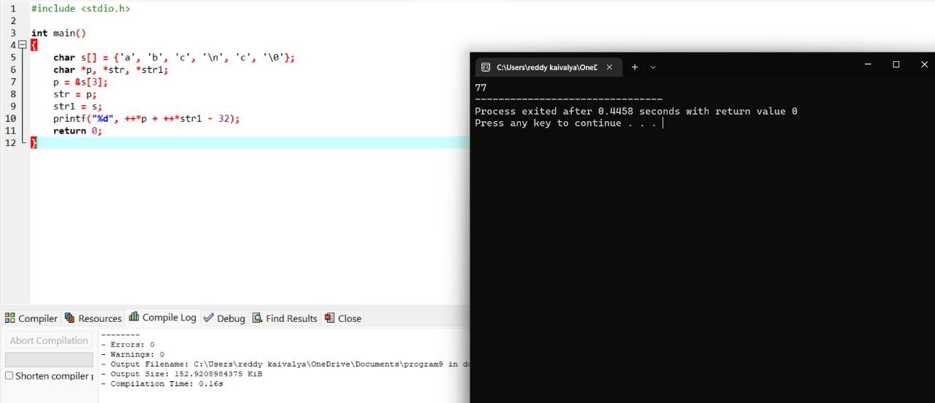

**14).write a program for matrix multiplication:**

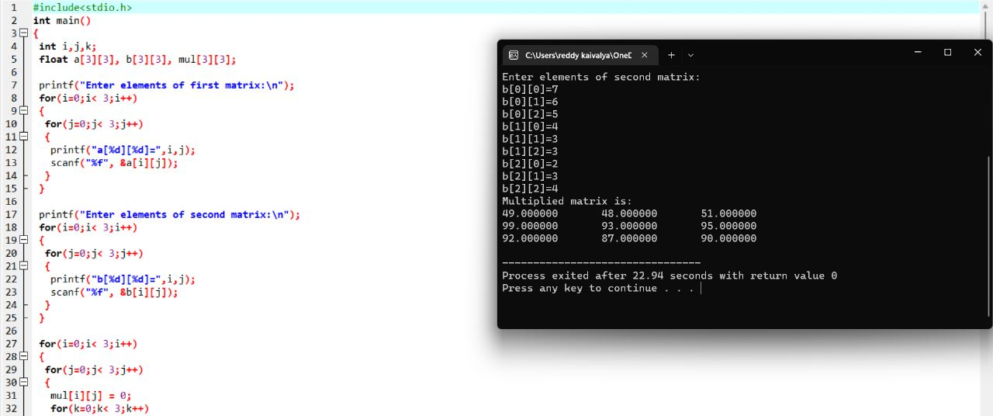

**15). To display the diagonal elements in a matrix array and to find the sum of them.**

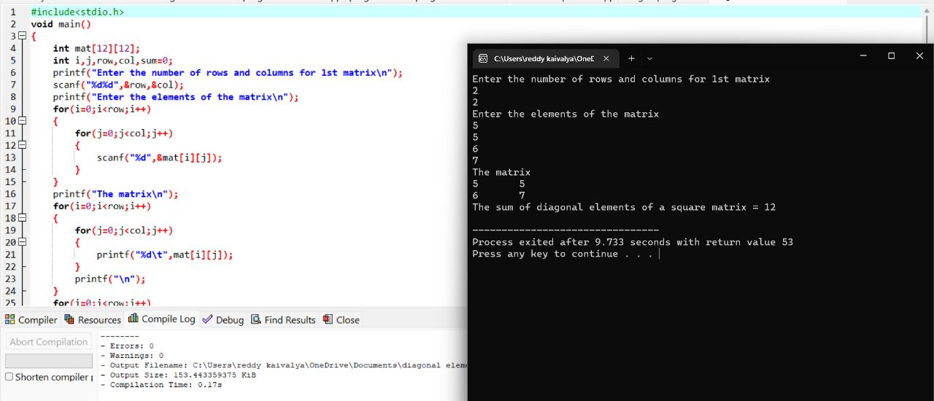

**16).** Write a program in C to swap elements using call by reference.

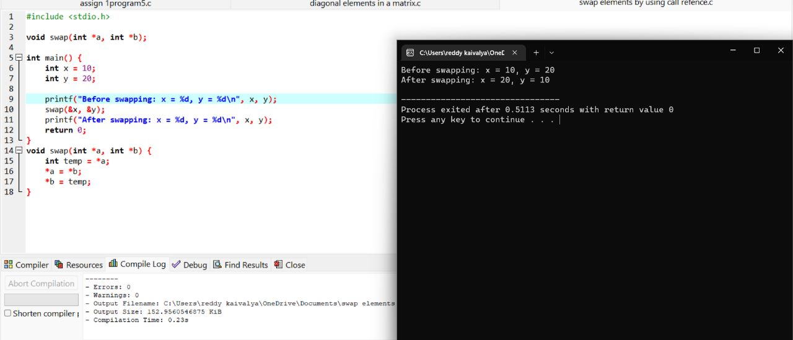17). Write C program to Copy file contents to another file.

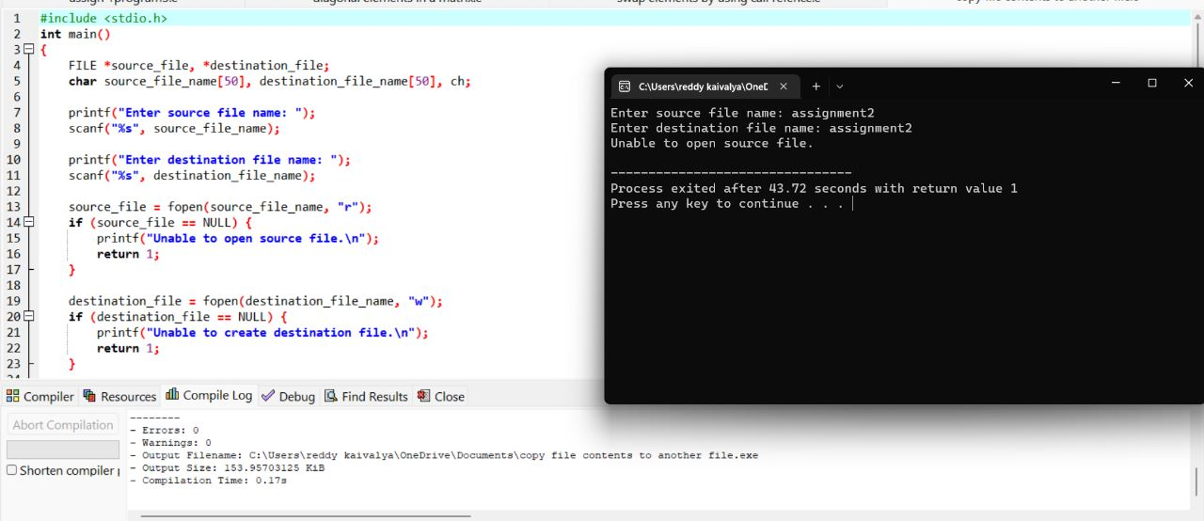

20) Write a Program to illustrates the use of continue statement:

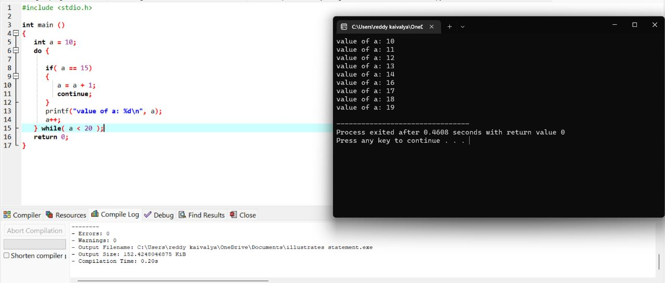

21. Write a program to calculate square and cube of an entered number. Use function as an argument:

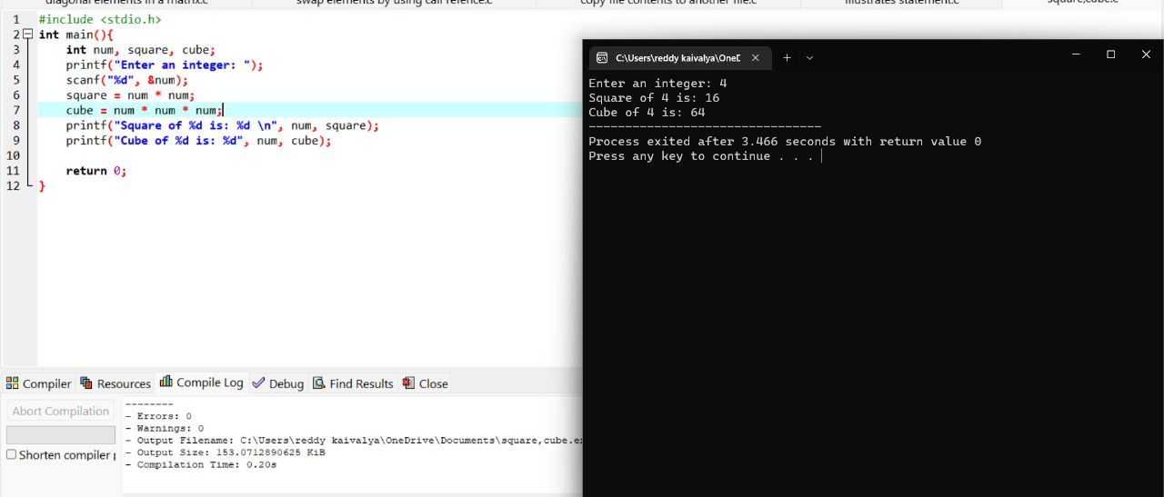

25). To implement a simple calculator using switch case statement:

